Carmel School


Semester 1 Examination, 2014

Question/Answer Booklet

CHEMISTRY 3A

Student Name:

Time allowed for this paper
Reading time before commencing work: ten minutes
Working time for paper: three hours

Materials required/recommended for this paper

To be provided by the supervisor
This Question/Answer Booklet
Multiple-choice Answer Sheet
Chemistry Data Sheet

To be provided by the candidate
Standard items: pens, pencils, eraser, correction fluid, ruler, highlighters
Special items: non-programmable calculators satisfying the conditions set out by the Curriculum Council for this course

Important note to candidates
No other items may be taken into the examination room. It is your responsibility to ensure that you do not have any unauthorised notes or other items of a non-personal nature in the examination room. If you have any unauthorised material with you, hand it to the supervisor before reading any further.
Structure of this paper

Section | Number of questions available | Number of questions to be answered | Suggested working time  (minutes) | Marks available | Percentage of exam
Section One:  Multiple-choice | 25 | 25 | 50 | 50 | 25
Section Two:  Short answer | 13 | 13 | 60 | 70 | 35
Section Three:  Extended answer | 6 | 6 | 70 | 75 | 40
 |  |  |  |  | 100

Instructions to candidates

1. The rules for the conduct of Western Australian external examinations are detailed in the Year 12 Information. Sitting this examination implies that you agree to abide by these rules.

2. Answer the questions according to the following instructions.

Section One: Answer all questions on the separate Multiple-choice Answer Sheet provided. For each question shade the box to indicate your answer. Use only a blue or black pen to shade the boxes. If you make a mistake, place a cross through that square, do not erase or use correction fluid, and shade your new answer. Marks will not be deducted for incorrect answers. No marks will be given if more than one answer is completed for any question.

Sections Two and Three: Write answers in this Question/Answer Booklet.

3. When calculating numerical answers, show your working or reasoning clearly unless instructed otherwise.

4. You must be careful to confine your responses to the specific questions asked and to follow any instructions that are specific to a particular question.

5. Spare pages are included at the end of this booklet. They can be used for planning your responses and/or as additional space if required to continue an answer.
  - Planning: If you use the spare pages for planning, indicate this clearly at the top of the page.
  - Continuing an answer: If you need to use the space to continue an answer, indicate in the original answer space where the answer is continued, i.e. give the page number. Fill in the number of the question(s) that you are continuing to answer at the top of the page.
Section One: Multiple-choice 25% (25 Marks)

This section has 25 questions. Answer all questions on the separate Multiple-choice Answer Sheet provided. For each question shade the box to indicate your answer. Use only a blue or black pen to shade the boxes. If you make a mistake, place a cross through that square, do not erase or use correction fluid, and shade your new answer. Marks will not be deducted for incorrect answers. No marks will be given if more than one answer is completed for any question.

Suggested working time for this section is 50 minutes.

1. Which of the following best explains why sodium and potassium are chemically similar to each other and different from magnesium?

(a) They are both metals.
(b) Their nuclei have the same number of protons.
(c) They each have one valence electron.
(d) They both react with water giving hydrogen.

2. The element X belongs to Group 15 of the periodic table. Which one of the following statements is true about the element X?

(a) X will be present as X³⁺ in ionic compounds.
(b) X will be present as X^{3–} in ionic compounds.
(c) X will mostly likely exist as uncombined atoms in its elemental state.
(d) X will not in general form compounds.

3. Which one of the following lists the elements in order of decreasing first ionisation energy, that is, from highest to lowest?

(a) Rb > K > Na > Li
(b) Li > Mg > B > A
(c) Ne > C > P > A
(d) Li > C > N > Ne

4. An element X has the following five successive Ionisation Energies (in kJ mol⁻¹)

502, 4569, 6919, 9550, 13356

What would be the formula of the compound formed when X reacts with chlorine?

(a) X₂Cl
(b) XCl
(c) XCl₂
(d) X₂Cl₃

5. Which one of the following statements is false regarding elements in the periodic table?

(a) The number of protons increases across a period.
(b) Atomic radius decreases across a period.
(c) Group 18 elements are generally unreactive.
(d) Electronegativity increases down a group.
6. In which of these compounds is the bond between the atoms not a nonpolar covalent
bond?

(a) Cl₂
(b) H₂
(c) HCl
(d) O₂

7. One can predict the shape of a molecule by drawing its Lewis structure and

(a) balancing the oxidation numbers.
(b) accounting for nonbonded pairs of valence electrons.
(c) determining the empirical formula.
(d) identifying the presence of polyatomic ions.

8. The less the electronegativity difference between two bonded atoms is, the greater the _________________of the bond.

(a) covalent character
(b) ionic character
(c) metallic character
(d) Both (b) and (c)

9. Even though the following molecules contain polar bonds, the only polar molecule is

(a) CCl₄.
(b) CO₂.
(c) NH₃.
(d) CH₄

- Which of the statements about ionic solids is false?
- Ionic solids conduct electricity when dissolved in water.
- Ionic solids are good conductors of electricity.
- Ionic solids can be formed by reacting an alkali metal with a halogen.
- Ionic solids form crystals
- Which of the following statements concerning the two isotopes of helium, 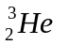and 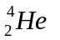, is false?

(a) Both of these atoms would behave in exactly the same manner in a chemical reaction.
(b) The atoms differ only in their mass, atoms being heavier thanatoms.
(c) atoms have an extra proton compared to atoms.
(d) In nature, atoms are more abundant than atoms.

12. Which one of the following substances has linear molecules?

(a) H₂O
(b) NH₃
(c) CO₂
(d) SO₂

13. Which of the following best describes a condition where it is necessary for the following
reaction to be at equilibrium?

CH₄(g) + H₂O(g) ←→ CO(g) + 3 H₂(g)

(a) All species are present in equal concentrations
(b) The concentrations of CH₄(g), H₂O(g) and CO(g) are equal
(c) The pressure in the reaction vessel remains constant
(d) The ratio [CO][H₂]³ is equal to 1
[CH₄][ H₂O]

- Which of the following equations shows only the reacting species (i.e. does not contain any spectator ions)?

(a) 2NaI(aq) + Pb(NO₃)₂(aq)  PbI₂(s) + 2NaNO₃(aq)
(b) Ag⁺(aq) + Cl⁻ AgCl(s)
(c) Ba²⁺(aq) + 2NO₃⁻(aq) + 2Na⁺ + SO₄²⁻(aq) BaSO₄(s) + 2Na⁺(aq) + 2NO₃⁻(aq)
(d) Ca²⁺(aq) + 2NO₃⁻(aq) + 2K⁺(aq) + CO₃²⁻(aq) 2K⁺ + 2NO₃⁻(aq) + CaCO₃(s)

- 20.0 cm³ of oxygen is reacted with 16.0 cm³ of carbon monoxide to produce carbon dioxide gas. If all gas volumes are measured at the same temperature and pressure, what would be the final composition of gases when the reaction is complete?

2CO(g) + O₂(g) 2CO₂(g)

(a) 40 cm³ of CO₂
(b) 12 cm³ of O₂ and 16 cm³ of CO₂
(c) 8 cm³ of O₂ and 40 cm³ of CO₂
(d) 8 cm³ of O₂ and 16 cm³ of CO₂

- A 2 L sample of a gaseous hydrocarbon is burnt in excess oxygen. The only products of the reaction are 8 L of CO₂(g) and 10 L of H₂O(g), all at 100ºC and 1 atm pressure. The formula of the hydrocarbon is:

(a) CH
(b) C₂H₄
(c) C₄H₁₀
(d) C₈H₁₀

- Calculate the concentration of sodium chloride, in parts per million (ppm), for a sample of water which is found to contain 0.0585 g of sodium chloride per 500 g of solution.

(a) 200 ppm (b) 20 ppm
(c) 58.5 ppm (d) 117 ppm
- Zn(s) + Cu²⁺(aq) Zn²⁺(aq) + Cu(s)

Consider the four statements below which describe what may happen in the above reaction:

I. The colour of the solution becomes paler.
II. The zinc metal becomes coated with copper metal.
III. The colour of the solution does not change.
IV. The solution changes to a more intense blue colour.

Which of these statements is/are true?

(a) I only.
(b) II only.
(c) I and II.
(d) II and III.

19. Graphite is unusual in that it can conduct electricity, yet is classified as a covalent network solid. Which one of the following statements best explains this?

(a) Each carbon atom in graphite forms double covalent bonds with two neighboring carbon atoms, leaving two electrons per atom delocalised and free to move throughout the structure.
(b) Each carbon atom in graphite forms double covalent bonds with two neighboring carbon atoms, leaving two electrons per atom delocalised and free to move between layers of covalently bonded carbon atoms.
(c) Each carbon atom in graphite shares three electrons with three neighboring carbon atoms. The fourth electron from each carbon atom is delocalised and free to move within the layers of covalently bonded carbon atoms.
(d) Each carbon atom in graphite shares three electrons with three neighboring carbon atoms. The fourth electron from each carbon atom is delocalised and free to move between layers of covalently bonded carbon atoms.

20. In order of increasing boiling points (i.e lowest to highest boiling point), you would arrange the substances: H₂O, CH₄, C₂H₆, CH₃CH₂OH and CH₃COCH₃ as follows:

(a) H₂O, CH₃CH₂OH, CH₃COCH_{3,} C₂H_{6,} CH_{4.}
(b) CH_{4,} C₂H_{6,} CH₃COCH₃, CH₃CH₂OH, H₂O.
(c) CH₃COCH_{3,} CH₃CH₂OH, CH_{4,} C₂H_{6,,}, H₂O.
(d) CH_{4,} CH₃CH₂OH, CH₃COCH₃, CH₃CH₂OH, C₂H_{6,} H₂O.

21. 100 mL of 1.00 M HCl is added to a 2 g piece of limestone, CaCO₃.
Which of the following will not increase the initial rate of this reaction?

  - adding 150 mL of 1 M HCl in place of 100 mL of 1 M HCl
  - adding 100 mL of 2 M HCl in place of 100 mL of 1 M HCl
  - heating the 100 mL of 1 M HCl before adding it to the limestone
  - adding 100 mL of 1 M HCl to powdered CaCO₃ in place of the single piece of limestone

22. Polyamides are a many-purpose and cost-effective class of plastics. Most of the polyamides used for technical applications possess high strength, stiffness and tenacity, and high chemical resistance and processability.Polyamides are also very important as thermoplastic materials.
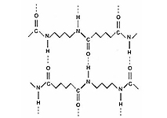
The strength of these fibres arises from the attractive forces, shown as dashed lines, between neighbouring polyamide chains. What is the name given to these forces of attraction?

(a) covalent bonds
(b) hydrogen bonds
(c) ionic bonds
(d) dispersion forces

23. Identify which one of the following pairs of solutions would produce a precipitate when mixed together.

(a) Fe(NO₃)₃ and K₃PO₄.
(b) NH₄NO₃ and Na₂CO_{3.}
(c) Ca(NO₃)₂ and NaCl.
(d) MgCl₂ and NaBr.

24. In a chemical reaction at constant temperature the addition of a catalyst

(a) affects the equilibrium constant.
(b) provides an alternative reaction pathway.
(c) increases the percentage yield at equilibrium.
(d) increases the fraction of molecules with more than a given kinetic energy.

25. Nitrogen (II) oxide and chlorine react according to the equation
2NO(g) + Cl₂(g) → 2NOCl(g); ΔH = –38 kJ mol–1
The activation energy for the forward reaction is 62 kJ mol–1.
The activation energy of the reverse reaction, in kJ mol–1, is

  - –62
  - 24
  - 38
  - 100

End of Section One
Section Two: Short answer 35% (70 Marks)

This section has 13 questions. Answer all questions. Write your answers in the space provided.

Spare pages are included at the end of this booklet. They can be used for planning your responses and/or as additional space if required to continue an answer.
  - Planning: If you use the spare pages for planning, indicate this clearly at the top of the page.
  - Continuing an answer: If you need to use the space to continue an answer, indicate in the original answer space where the answer is continued, i.e. give the page number. Fill in the number of the question(s) that you are continuing to answer at the top of the page.

Suggested working time for this section is 60 minutes.

Question 26 (2 marks)

Write the equilibrium constant expression for each of the following.

Equation | 4 HCl_{(g)} + O_{2 (g)} 2 H₂O_{(g)} + 2 Cl_{2 (g)}
Equilibrium constant expression
(1 mark)

Equation | OCl –_{(aq)} + H₂O_{(l)} HOCl_{(aq)} + OH⁻_{(aq)}
Equilibrium constant expression
[1 mark]

Question 27 (4 marks)

Write the equation for the reaction that occurs in each of the following procedures. If no reaction occurs, write ‘no reaction’. For full marks, chemical equations should refer only to those species consumed in the reaction and the new species produced. These species may be ions [for example Ag⁺(aq)], molecules [for example NH₃(g), NH₃(aq), CH₃COOH()] or solids [for example BaSO₄(s), Cu(s), Na₂CO₃(s)].

(a) copper carbonate solid is mixed with hydrochloric acid solution. [2 marks]
Equation:

(b) barium metal is mixed with sulfuric acid solution. [2 marks]
Equation:

Question 28 (7 marks)

a) Use 2 examples to explain how VSEPR(Valence shell electron pair repulsion) theory helps explain a molecule’s shape?

[4 marks]
b) How is polarity related to bond strength?

[3 marks]
Question 29 (4 marks)

Chlorine bleach contains the active ingredient sodium hypochlorite (NaOCl) at a concentration of 5.25%. If the required concentration to kill bacteria is 25-200ppm of sodium hypochlorite,

- What minimum amount of bleach would you need to add to a bucket of water holding 3.00 L of water? (assume density of bleach solution is 1.00gmL⁻¹)
[3 marks]

- Discuss any other factors that might affect how long the bleach takes to kill the bacteria. [1 marks]

Question 30 (5 marks)

In order to help prevent tooth decay, fluoride ions at a level of 0.9 mg L^{–1} of F– are added to Melbourne’s public water supplies. The fluoride ions are obtained by adding sodium fluoride (NaF) to the water.

- Calculate the mass of sodium fluoride in mg that must be present in one litre of water to produce a concentration of fluoride ions of 0.90 mg L^{–1}.

[2 marks]
- What mass of sodium fluoride, in kilogram, must be added to a 750 ML reservoir (1 ML = 10⁶ L) to produce a concentration of fluoride ions of 0.90 mg L^{–1}?

[1 mark]
- Calculate the number of fluoride ions swallowed by a person who drank one litre of water from the reservoir.

[2 marks]
Question 31 (4 marks)

Write observations for any reactions that occur in the following procedures. In each case describe in full what you would observe, including any

- colours
- odours
- precipitates (give the colour)
- gases evolved (give the colour or describe as colourless).

If no change is observed, you should state this.

(a) manganese dioxide is added to hydrogen peroxide solution. [2 marks]
Observation:

(b) copper nitrate solution is mixed with sodium hydroxide solution. [2 marks]
Observation:

Question 32 (8 marks)

Complete the following table.

Molecule | Major type of intermolecular attraction  (choose from dispersion forces, dipole-dipole or hydrogen bonding) | Boiling point ranking  (1 = highest,  4 = lowest)
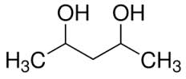

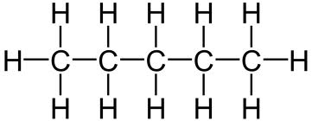
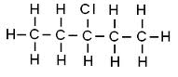
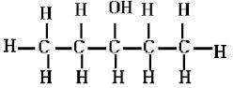
Question 33 (6 marks)

The graph shows the variation in concentration of reactant and products as a function of time for the following system.
COCl₂(g) → Cl₂(g) + CO(g) ΔH =+108 kJ
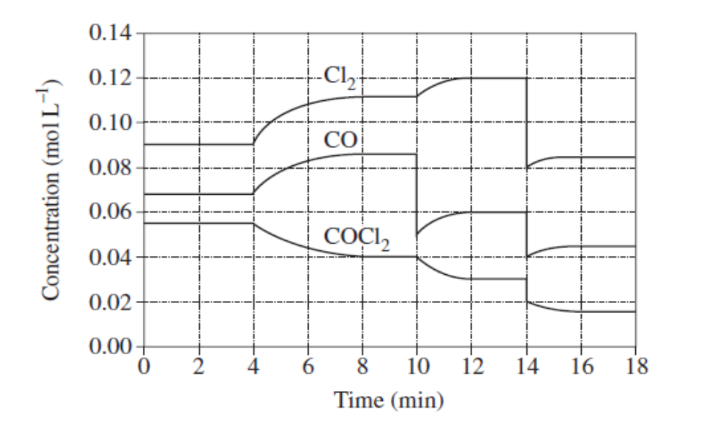
Identify and explain each of the changes in conditions that have shaped the curves during the time the system was observed.

Question 34 (6 marks)

For each species listed in the table below, draw the structural formula, representing all valence shell electron pairs either as : or as — and state or draw the shape of the molecule or ion.
(for example, water | 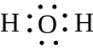 | or | 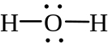 | or | 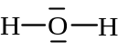 | bent

Molecule | Structural formula  (showing all valence shell electrons) | Shape  (sketch or name) | Polarity
Hydrogen-phosphate ion

ethane

Question 35 (6 marks)

At a particular temperature, iodine trichloride dissociates into iodine gas and chlorine gas according to the following equation:

2ICl_{3(g)} → I_{2(g)} + 3Cl_{2(g)} ΔH = 240 kJ

Initially 0.35 mol of ICl_{3(g)} was introduced into a 1.0 L container and allowed to come to equilibrium. At equilibrium there was 0.45 mol L^{–1} of Cl_{2(g).}

a) Write the equilibrium constant expression for this reaction.

[1 mark]
b) Calculate the value of K at this temperature.

[3 marks]
c) What are two consequences of increasing the temperature of the mixture at equilibrium?

[2 marks]
Question 36 (6 marks)

In class you have looked at the equilibrium between two cobalt complex ions, shown in the equation below. This equilibrium is set up when cobalt chloride is dissolved in dilute hydrochloric acid
.
Co(H₂O)₆²⁺ + 4Cl⁻ ↔ CoCl₄²⁻ + 6H₂O
red deep blue
Both the red ion and the deep blue ion are present in the reaction mixture which is therefore purple.
Three test tubes are set up, each containing some of the equilibrium mixture. Each of the tubes is treated as described below. In each case state how the equilibrium will shift, and what will be observed.

What is done | How the equilibrium shifts.  Write ‘→’, ‘←’ or ‘no change’ | What is observed.  Give the complete observation.
A little concentrated hydrochloric acid is added to the first tube.

A little silver nitrate
solution is added to
the second tube.

A little concentrated cobalt nitrate solution is added to the third tube.

Question 37 (7 marks)

- The graph below shows the first ionisation energies for the group 1 elements.

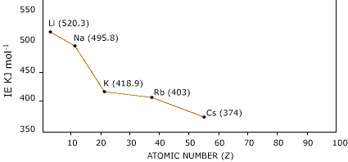

Explain the trend shown in the graph.
________________________________________________________________________________________________________________________________________________________________________________________________________________________________________________________________________________________
[2 marks]
- How would the graph be similar and different if group 17(halogens) had been used
________________________________________________________________________________________________________________________________________________________________________________________________________________________________________________________________________________________
[2 marks]
- An element has the first five successive ionisation energies.
 | 1st | 2nd | 3rd | 4th | 5th
Successive ionisation energy(kJ/mol) | 600 | 1200 | 4900 | 6500 | 8200

Which group does the element belong to and explain your reasons for this choice.
________________________________________________________________________________________________________________________________________________________________________________________________________________________________________________________________________________________
[3 marks]
Question 38 (5 marks)

The nitrogen content of bread was determined using the following procedure:
- A sample of bread weighing 2.80 g was analysed.
- The nitrogen in the sample was converted into ammonia.
- The ammonia was collected and completely neutralised in 30.0 mL of 0.125 mol L⁻¹ hydrochloric acid.

(a) Write a balanced ionic equation for the reaction involving hydrochloric acid.

[1 mark]

(b) Calculate the moles of hydrochloric acid.

[1 mark]
(c) Calculate the moles of ammonia.

[1 mark]

(d) Calculate the percentage by mass of nitrogen in the bread.

[2 marks]

End of Section Two

This page is left blank intentionally
Section Three: Extended answer 40% (75 Marks)

This section contains six (6) questions. You must answer all questions. Write your answers in the space provided.

Spare pages are included at the end of this booklet. They can be used for planning your responses and/or as additional space if required to continue an answer.
  - Planning: If you use the spare pages for planning, indicate this clearly at the top of the page.
  - Continuing an answer: If you need to use the space to continue an answer, indicate in the original answer space where the answer is continued, i.e. give the page number. Fill in the number of the question(s) that you are continuing to answer at the top of the page.

Suggested working time for this section is 70 minutes.

Question 39 (13 marks)

Fungi and mildews can cause great damage to grape vines. One spray used to combat these diseases is called Bordeaux mixture. A home gardener who wishes to treat his grapes with Bordeaux mixture prepares a mixture using the instructions given below.

1. Add 25.0 g of calcium hydroxide powder to 25.0 g of copper(II) sulfate pentahydrate powder.
2. Mix these powders with a small amount of water to make a paste.
3. Add the paste to 5.00 L of water and mix well.
4. Use the mixture immediately after preparation.

(a) Complete and balance the equation for the reaction that occurs after the powders are mixed with water. [2 marks]
Equation: Ca(OH)₂(aq) + CuSO₄(aq) →

(b) Determine the limiting reagent for the above reaction. [4 marks]

(c) Calculate the mass of reagent in excess. [2 marks]

(d) What colour (if any) will the solution have? [1 mark]

(e) The concentration of Bordeaux mixture is traditionally given by the percentage of the weight of copper(II) sulphate to the weight of water in the mixture. If the density of the water is 1.00 g mL -1, calculate the concentration of the mixture. [2 marks]

(f) The most effective Bordeaux mixture actually has more copper(II)sulphate than calcium hydroxide. In fact there can be half the mass of calcium hydroxide present and it will still be effective. These mixtures rarely use less calcium hydroxide as it tends to deteriorate by reacting with carbon dioxide in the air. Show the equation for the calcium hydroxide deteriorating. [2 marks]

Question 40 (12 marks)

The main source of the element magnesium in Australia is the ore magnesite, in which magnesium is present as magnesium carbonate (MgCO₃).
a) Calculate the percentage by mass of magnesium in magnesium carbonate.

[1 mark]
b) Magnesium carbonate reacts with dilute hydrochloric acid, Write a balanced equation for this reaction.

____________________________________________________________________________
[1 mark]

A series of laboratory experiments was set up to study the rate of this reaction under some different conditions. The initial reaction rate was determined by measuring the rate of evolution of CO₂ in a gas syringe as shown in the following diagram.

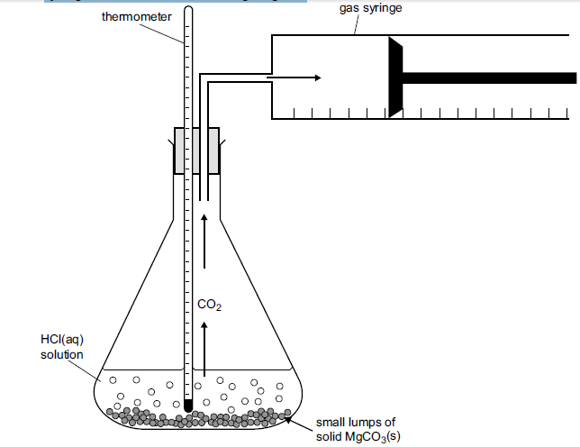

Four experiments were carried out as follows. In each case, the amount of HCl present was in excess.
Experiment | [HCl] (mol L⁻¹⁾ | Mass of MgCO_{3(s)} | Initial temp in °C | Final temp in °C | Initial rate of CO₂ evolution in  mL min^{–1}
1 | 0.10 | 1.0 | 20 | 25 | 5
2 | 0.10 | 1.0 | 30 | 35 | 50
3 | 0.10 | 2.0 | 20 | 30 | 10
4 | 0.20 | 1.0 | 20 | 25 | 20
c) Results from experiment 4 are plotted on the sketch graph below. On the same axes, sketch the results from the other experiments.
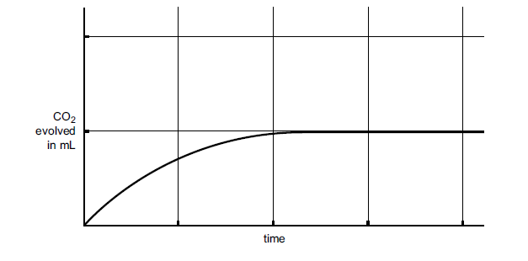[3 marks]
d) Comment on the factor which increases rate most significantly.

[1 mark]
e) You are now going to use the trial performed to plan an investigation into the factor you think was most significant. Outline what you would do in your investigation.

[6 marks]
Question 41 (15 marks)

A chlorofluorocarbon (a compound containing only chlorine, fluorine and carbon) is analysed by preparing two identical samples of the compound of mass 2.320 g. The first sample is burnt in excess oxygen gas to convert all the carbon it contains into carbon dioxide. The second sample of the compound is chemically treated to convert all the chlorine it contains into hydrochloric acid.

a) Given that the mass of carbon dioxide produced is 0.9267 g and the hydrochloric acid produced requires 17.2 mL of a 3.062 mol L⁻¹ ammonia solution for complete neutralisation, calculate the empirical formula of the chlorofluorocarbon.

[5 marks]

b) When a 1.503 g sample of the compound is vaporised in the absence of air, the vapour occupies 152.8 mL at S.T.P. From this data, calculate the molecular formula of the compound.

[3 marks]

c) Draw a possible structure of the chlorofluorocarbon.

[2 marks]

d) The reactions of fluorine and chlorine with methane are quite vigorous. Fluorine is the most reactive. If no precautions are taken, a mixture of fluorine and methane explodes whilst the reaction between methane and chlorine is easily controllable.
In a reaction of methane with chlorine the activation energy is 242 kJ and the heat of reaction is -105 kJ.
Draw labelled energy profile diagram for this reaction to scale. On the same diagram predict what the energy profile diagram for the reaction of methane and fluorine would look like.

Progress of reaction
Potential energy (kJ)

[5 marks]
Question 42 (10 marks)

Arsenic is analysed in the following way.
Samples are heated strongly with excess sodium peroxide so the mixture melts and the
arsenic is converted to sodium arsenate:

2As + 5Na₂O₂ → 2Na₃AsO₄ + 2Na₂O

The product is cooled and dissolved in water.

Na₃AsO₄ → 3Na⁺ + AsO₄ ³⁻
Dilute nitric acid is added and the solution is boiled and the arsenate ion is converted to ‘dihydrogenarsenate’ ion.

AsO₄ ³⁻ + 2H⁺ → H₂AsO₄ ⁻

Silver nitrate is added to precipitate silver arsenate:

H₂AsO₄ ⁻ + 3Ag⁺ → Ag₃AsO₄ + 2H⁺

The silver arsenate is filtered and washed. It is then dissolved in dilute nitric acid to produce silver ion:

Ag₃AsO₄ + 3H⁺ → H₃AsO₄ + 3Ag⁺

The silver ion is then reacted with potassium thiocyanate solution, as follows:

Ag⁺ + NCS⁻ → AgNCS

A 0.0320g sample of commercial arsenic metal is treated as described, and ultimately when processed it requires 24.36mL of 0.0506 mol L⁻¹ potassium thiocyanate solution in the last step.

- Use the above equations to work out how many moles of thiocyanate ion will react
with the silver ion produced from 1 mole of commercial arsenic.

[3 marks]

- Use this value to calculate the percentage by mass of arsenic in the sample

[7 marks]

Question 43 (13 marks)

Chromium metal occurs mainly as the green mineral chromite, Fe₂O₃.Cr₂O₃. It is extracted from chromite by heating the mineral in air with sodium carbonate to form sodium chromate according to the following balanced equation:

2Fe₂O₃.Cr₂O₃ + 4Na₂CO₃ + 3O₂(g) → 2Fe₂O₃ + 4Na₂CrO₄(s) + 4CO₂(g)

(a) Calculate the mass of sodium carbonate needed to react with 1.00 tonne of chromite.
[Hint: 1 tonne = 10³ kg or 10⁶ g.]

[5 marks]

(b) What volume of oxygen gas measured at 30.0ºC and 98.0 kPa pressure is required
for the reaction in (a) above?

[4 marks]

(c) If the reaction is only 78% efficient calculate the amount of sodium chromate produced from the reaction.

[4 marks]
Question 44 (12 marks)

The melting point and boiling points of four substances are listed in the table below. Describe how an understanding of the forces between atoms in these substances can be used to explain the wide range of the values.

Substance | Melting Point (ºC) | Boiling Point (ºC)
F₂ | -219 | -188
HF | -83 | 19.5
NaF | 993 | 1700
SiC | Decomposes at 2000 | Not applicable

Your answer should be approximately one to two pages in length.

End of questions
Additional working space

